Answers to questions in

Lab 1: Filtering operations

Name: __Mert Alp Taytak__________________________________ Program: __EECS_

Instructions: Complete the lab according to the instructions in the notes and respond to the questions stated below. Keep the answers short and focus on what is essential. Illustrate with figures only when explicitly requested.

Good luck!

___________________________________________________________________________

Question 1: Repeat this exercise with the coordinates p and q set to (5, 9), (9, 5), (17, 9),
(17, 121), (5, 1) and (125, 1) respectively. What do you observe?

Answers:

My observations are that:
- Very different points set to 1 at Fhat can show up as the same point after centering.
- No practical difference can be observed between real(F) and imag(F).
- If there is some sort of symmetry between centered Fhat points between figures, same symmetry can be observed in rest of the subplots too.
- Amplitude is the same for all figures, because we start with a single 1 in a matrix of 0s for all figures. Moreover, where the 1 is does not matter.
- Wavelength is correlated with modulus of the centered Fhat point.
- For a centered Fhat = (uc, vc), corresponding real(F) and imag(F) plots have abs(uc) “waves” in the (1, 0) direction and abs(vc) “waves” in the (0, 1) direction.
___________________________________________________________________________

Question 2: Explain how a position (p, q) in the Fourier domain will be projected as a sine wave in the spatial domain. Illustrate with a Matlab figure.

Answers:

From the lectures we know that rotation in the spatial domain results in the same rotation in the Fourier domain and vice versa. We also know that in the 1D case, a point w in the Fourier domain is projected as a sine wave with frequency w in the spatial domain.
It follows that a point (p, q), centered to (u, v), in the Fourier domain would be projected as a sine wave of frequency sqrt(u^2 + v^2) in the direction (u, v).
Following are results of fftwave applied to four points of modulus 5 from the first quadrant.
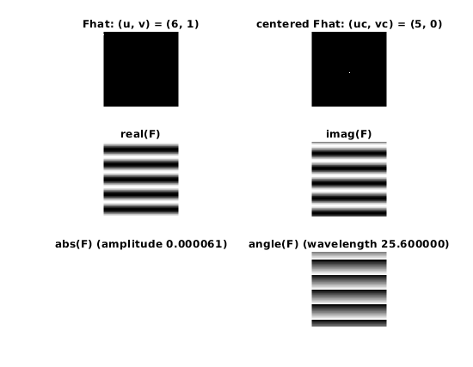 | 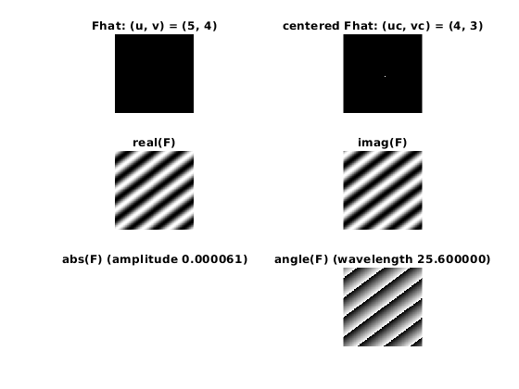
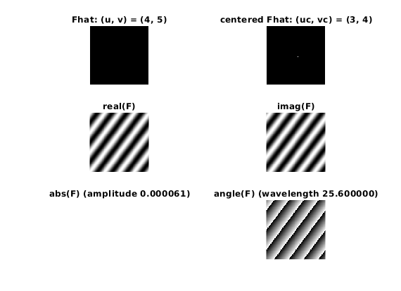 | 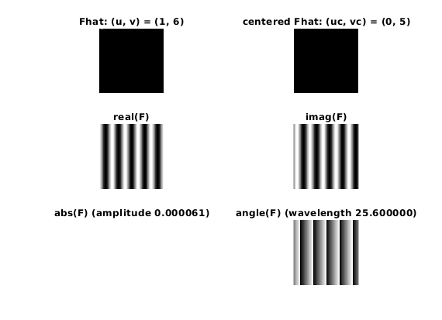

Observe that direction of the sine wave plotted in real(F) subplots follow the direction of centered Fhat.
___________________________________________________________________________

Question 3: How large is the amplitude? Write down the expression derived from Equation (4) in the notes. Complement the code (variable amplitude) accordingly.

Answers:

In our case, all points in Fhat is 0 with exception of (u, v). Then:

Since we are looking at amplitude precisely at x = (u, v),

Note that MATLAB implementation uses the factor 1 / N², so code is implemented accordingly.
___________________________________________________________________________

Question 4: How does the direction and length of the sine wave depend on p and q? Write down the explicit expression that can be found in the lecture notes. Complement the code (variable wavelength) accordingly.

Answers:

Direction is given by the vector (u_{centered}, v_{centered}).
___________________________________________________________________________

Question 5: What happens when we pass the point in the center and either p or q exceeds half the image size? Explain and illustrate graphically with Matlab!

Answers:

fftshift transforms range of values from [0, N-1] to [- N/2, N/2 - 1] for each dimension in the Fourier domain. Thus, when a coordinate exceeds half the image size the frequency changes sign. Which has the effect of “teleporting” a point to other end of the axis, as if the Fourier dimension was a sphere’s surface laid out like a square.
Following figures show what happens when we switch between quadrants around the center point.
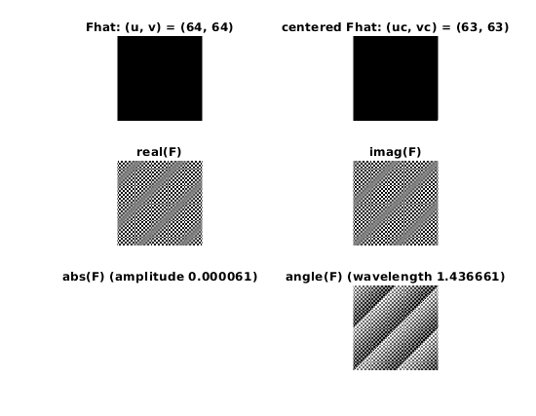 | 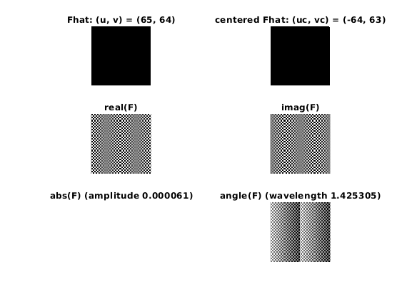
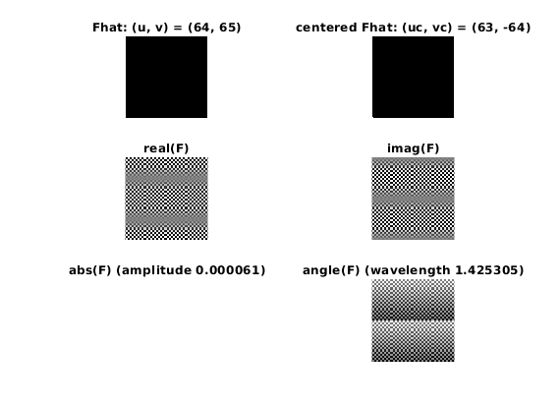 | 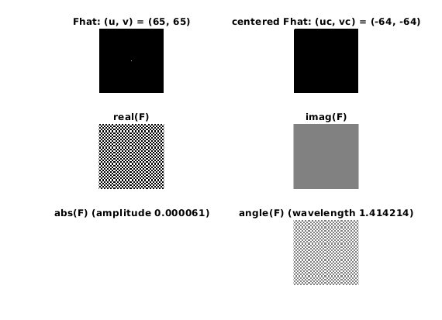

___________________________________________________________________________

Question 6: What is the purpose of the instructions following the question What is done by these instructions? in the code?

Answers:

Those instructions allow us to calculate centered u, v coordinates u_{c}, v_{c} where (u_{c}, v_{c}) point is where (u, v) would land after the application of fftshift. Shifting of the dimensions were already discussed previously. Another thing of note is that MATLAB indexes arrays starting from 1, hence the subtraction of 1 in the code.
___________________________________________________________________________

Question 7: Why are these Fourier spectra concentrated to the borders of the images? Can you give a mathematical interpretation? Hint: think of the frequencies in the source image and consider the resulting image as a Fourier transform applied to a 2D function. It might be easier to analyze each dimension separately!

Answers:

Equation (3) can be rewritten as follows:

Then, considering our matrix F, we can replace variables with their respective values:

Rightmost sum is 1 only when y = 0, by the Dirac delta function. Thus we can only have non-zero values on the y = 0 line. On that line we have a periodic function with the complex exponential. Hence, we have periodic bars on a single line y = 0.
Intuitively this makes sense, because the matrix has change only in one direction. Therefore, change in the other direction is 0 and we only get a single line y = 0 where spectra is visible.
Explanation for G works the same way with dimensions exchanged. For H works by linearity.
___________________________________________________________________________

Question 8: Why is the logarithm function applied?

Answers:

The logarithm function is great at compressing a range while still making different values distinguishable. Thus, larger values do not dominate the color range and make smaller values invisible.
___________________________________________________________________________

Question 9: What conclusions can be drawn regarding linearity? From your observations can you derive a mathematical expression in the general case?

Answers:

Graphically we can see that Fourier transformation is linear. Following is the expression:

___________________________________________________________________________

Question 10: Are there any other ways to compute the last image? Remember what multiplication in Fourier domain equals to in the spatial domain! Perform these alternative computations in practice.

Answers:

By the convolution theorem, multiplication in the spatial domain is equal to inverse Fourier transform of convolution in the Fourier domain. In formula:

Hence, there is another way to compute the last image.
___________________________________________________________________________

Question 11: What conclusions can be drawn from comparing the results with those in the previous exercise? See how the source images have changed and analyze the effects of scaling.

Answers:

In the previous exercise region of 1s had the shape of a square in the middle, in this exercise it is a rectangle instead. If the square had dimension 2Nx2N the rectangle has dimensions 4NxN. The scaling factors of 2 and ½ can be observed in the rectangular regions in the Fourier domain with exactly the same factors.
___________________________________________________________________________

Question 12: What can be said about possible similarities and differences? Hint: think of the frequencies and how they are affected by the rotation.

Answers:

Rotation in the spatial domain results in the same rotation applied in the Fourier domain. Moreover, this rotation is revertible. This can be observed in the following figure:
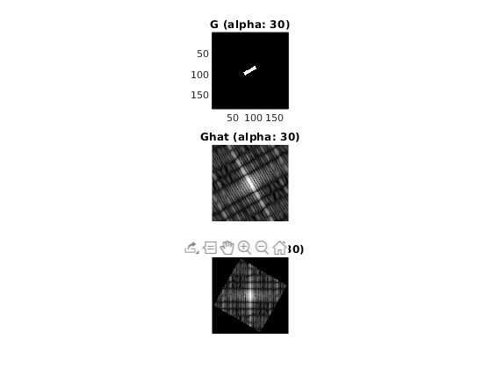

___________________________________________________________________________

Question 13: What information is contained in the phase and in the magnitude of the Fourier transform?

Answers:

In the phase of Fourier transform general shape information is contained, e.g. edges. In the magnitude brightness information is contained.

___________________________________________________________________________

Question 14: Show the impulse response and variance for the above-mentioned t-values. What are the variances of your discretized Gaussian kernel for t = 0.1, 0.3, 1.0, 10.0 and
100.0?

Answers:

Following figures contain the necessary information:
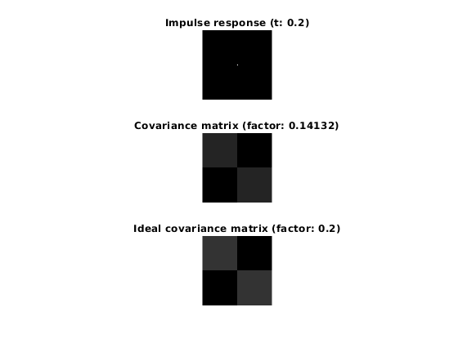 | 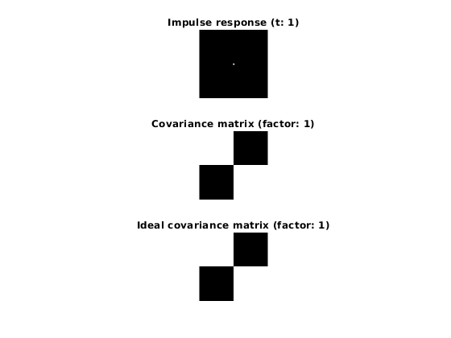
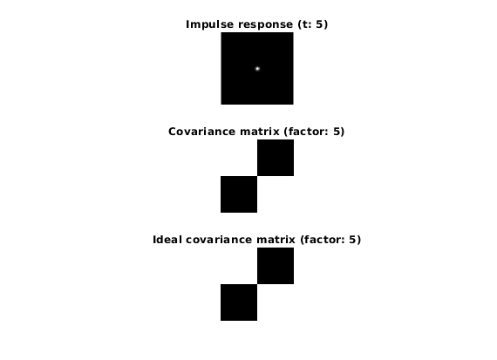 | 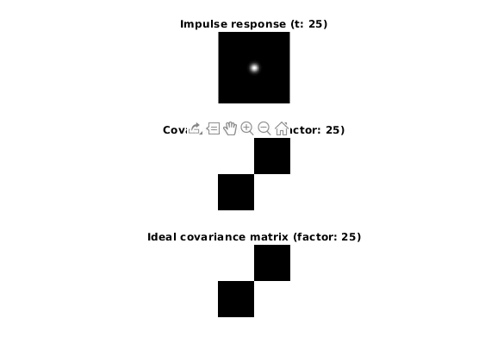
___________________________________________________________________________

Question 15: Are the results different from or similar to the estimated variance? How does the result correspond to the ideal continuous case? Lead: think of the relation between spatial and Fourier domains for different values of t.

Answers:

Results are similar to the estimated variance in general. For larger values of t, difference is non-existent. Smaller the t, higher the difference.
___________________________________________________________________________

Question 16: Convolve a couple of images with Gaussian functions of different variances (like t = 1.0, 4.0, 16.0, 64.0 and 256.0) and present your results. What effects can you observe?

Answers:

Higher the t value, more blurred the resulting image gets. That is because Gaussian filter acts as a low pass filter and higher t lowers the threshold.
___________________________________________________________________________

Question 17: What are the positive and negative effects for each type of filter? Describe what you observe and name the effects that you recognize. How do the results depend on the filter parameters? Illustrate with Matlab figure(s).

Answers:

Following are figures for various results:

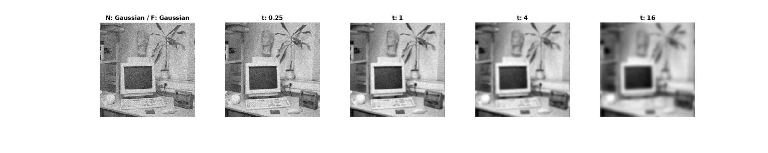
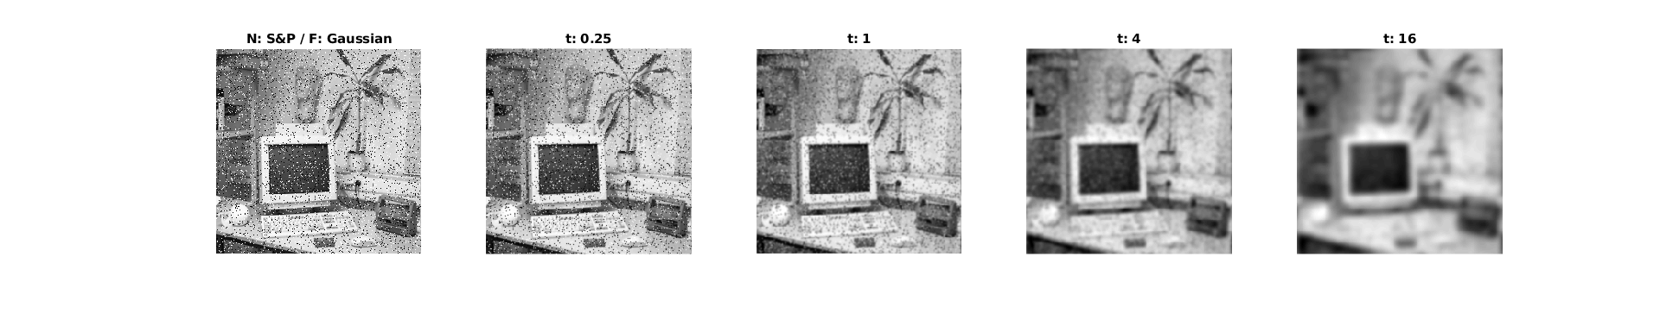
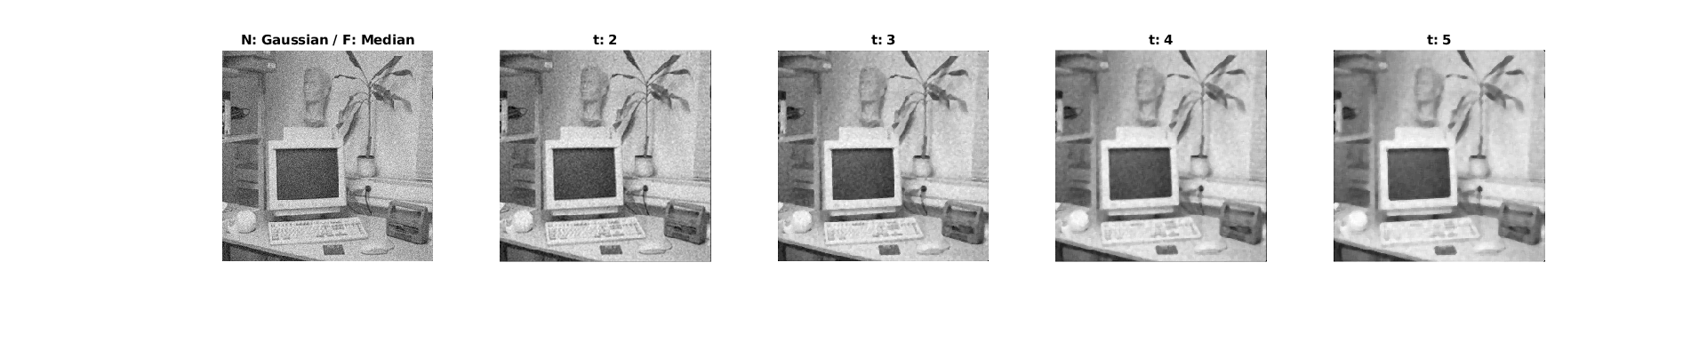
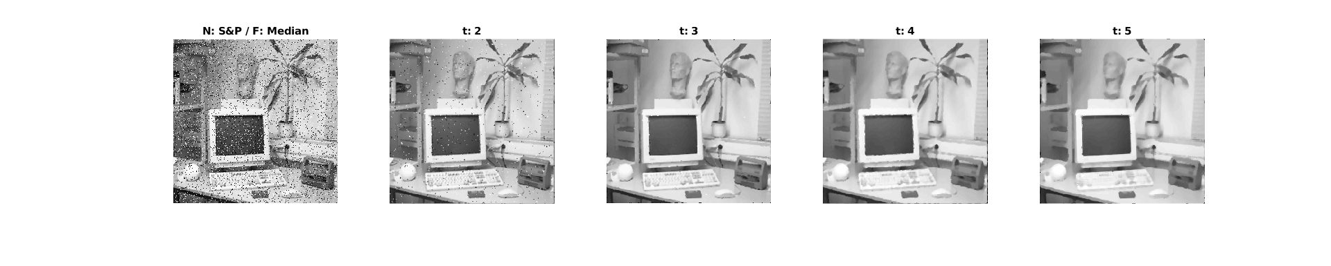
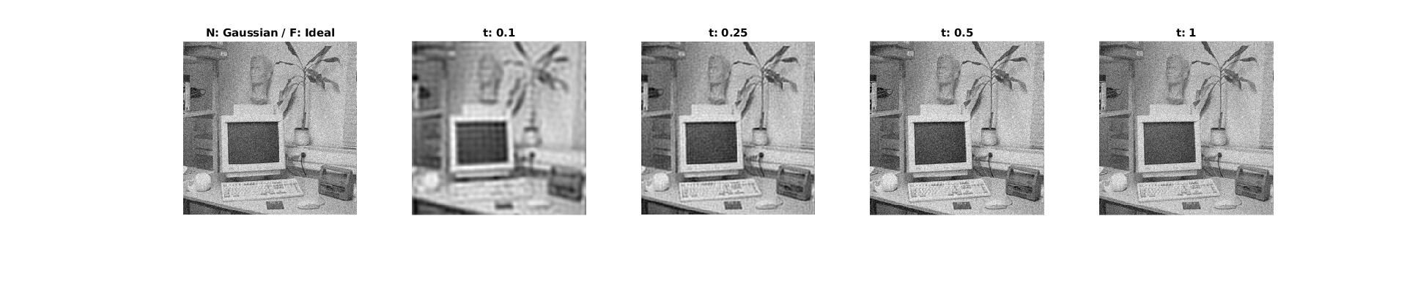
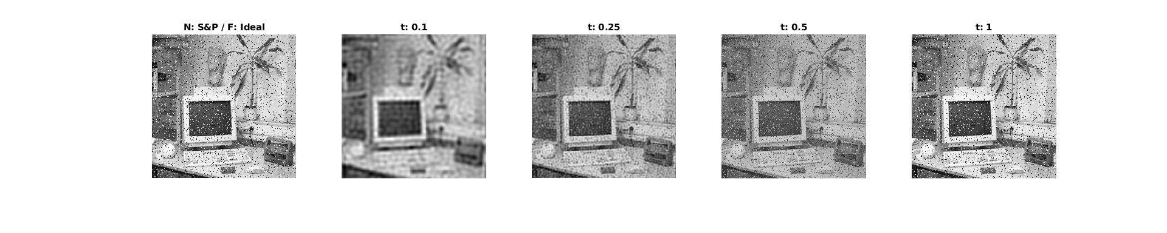

My observations are that:
- Gaussian filter is good at dealing with smoothing out small variances over the picture, e.g. Gaussian noise. However, high variance noise such as salt and pepper requires a lot of blurring to overcome. Which is undesirable.
- Median filter is very good at dealing with sporadic high variance noise like salt and pepper. It is decently effective with Gaussian noise and does not lower image quality either.
- Ideal low pass filter is not good at dealing with salt and pepper noise. It is decent against Gaussian noise.
Effects of parameters are that:
- For the Gaussian filter, higher the parameter blurrier the picture.
- For the median filter, higher the parameter more painting like the picture gets. Large sections of the picture becomes of a single color. Which introduces artifacts.
- For the low pass filter, higher the parameter blurrier the picture. Particularly edges get smoothed.
___________________________________________________________________________

Question 18: What conclusions can you draw from comparing the results of the respective methods?

Answers:

- Gaussian filter is good for Gaussian noise, bad for salt and pepper noise.
- Median filter is very good for salt and pepper noise, decent for Gaussian noise.
- Ideal low pass filter is not particularly great with anything. It also introduces grid-like artifacts that are very noticeable at lower thresholds.
___________________________________________________________________________

Question 19: What effects do you observe when subsampling the original image and the smoothed variants? Illustrate both filters with the best results found for iteration i = 4.

Answers:

Following is the figure for best results:

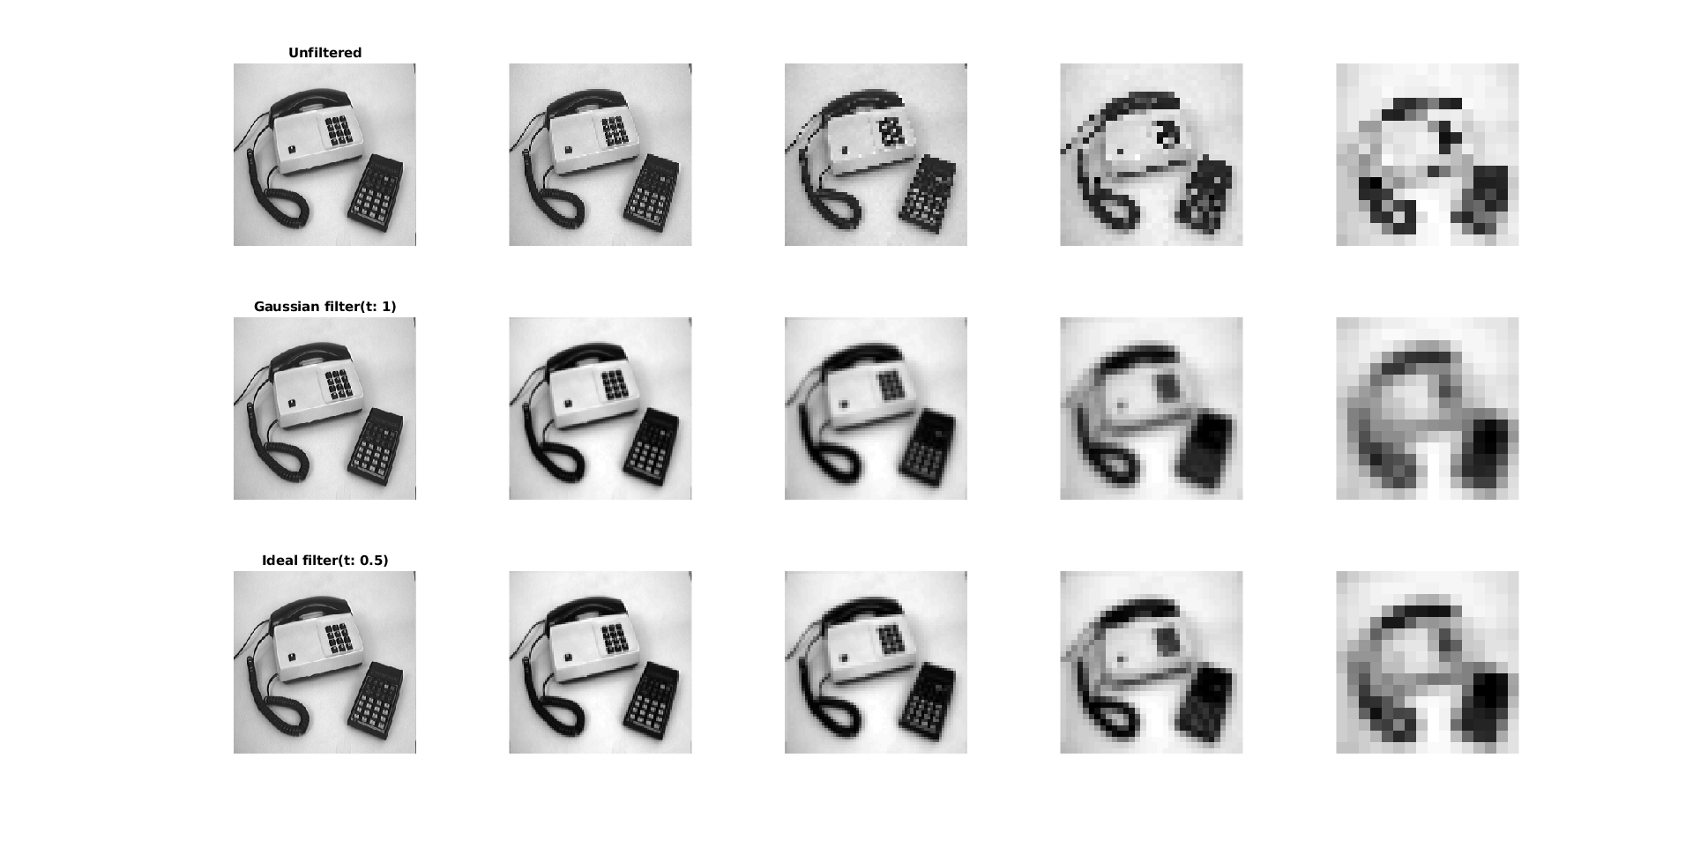

My observations are that filtering before sampling helps. Particularly, edges are preserved better.
___________________________________________________________________________

Question 20: What conclusions can you draw regarding the effects of smoothing when combined with subsampling? Hint: think in terms of frequencies and side effects.

Answers:

Per the Nyquist theorem, maximum frequency that can be kept is correlated with sampling rate. Smoothing an image before sampling helps move the information from higher frequencies to lower frequencies. Thus, more information is kept through subsampling iterations.
___________________________________________________________________________

